Static Tars (No Motors) – Assembly (WIP)

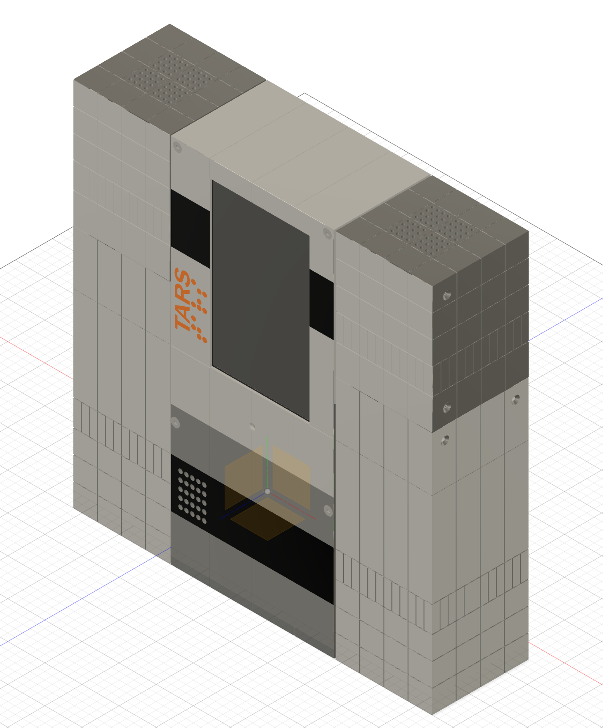

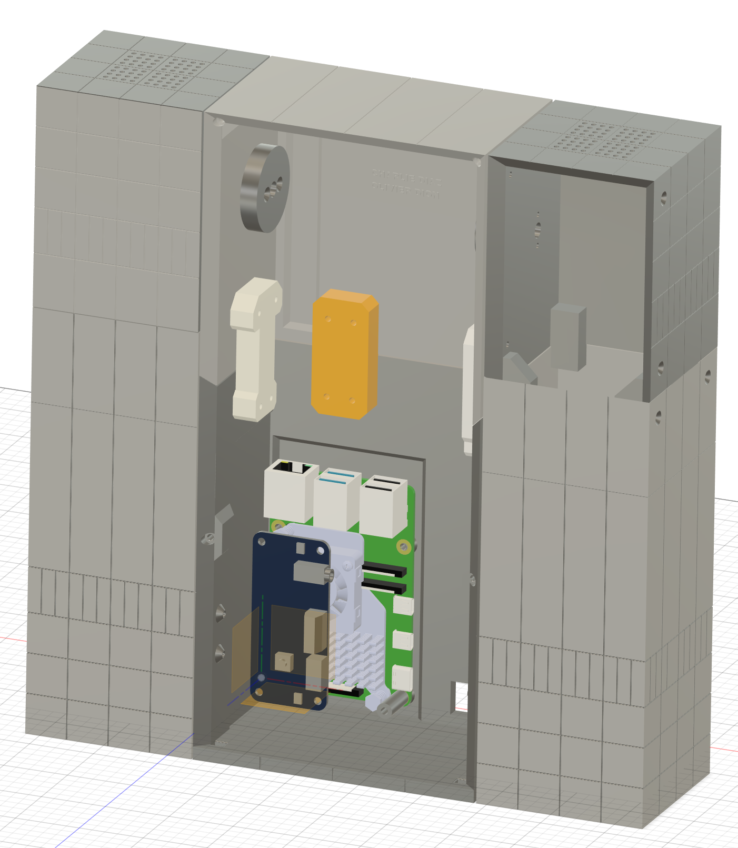

First install the active cooler on the raspberry pi and secure the raspberry pi in place in the lower case
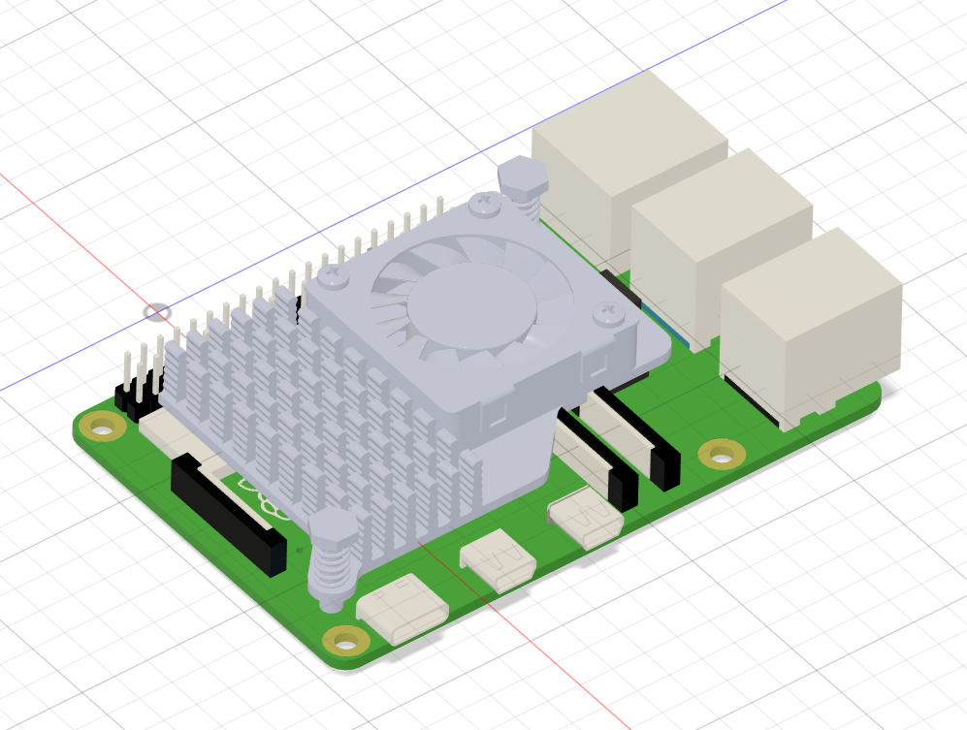

Install the drivers.

Install the drivers for the Audio Hat
git clone https://github.com/waveshare/WM8960-Audio-HAT
cd WM8960-Audio-HAT
sudo ./install.sh
reboot your raspberry pi.
You should now see a the speaker and microphone controls.

Add the Screen config.txt configuration.
Open the config.txt file in the root directory of the TF card, add the following code at the end of the config.txt, save and safely eject the TF card.
dtoverlay=vc4-kms-v3d
dtoverlay=vc4-kms-dsi-waveshare-panel,7_0_inchC,dsi0
Everything else is just bolted toghether using M2.5 screws.
1. Assemble the legs first.
2. There is room in the legs to add the Speakers.
3. Use the Leg Swivel Interior Fastener parts to secure each leg to the case, The legs can rotate.

